Task 1

Forms of Business Entities

Sole Proprietorship
Tax Implications
In a sole proprietorship, the owner and the business are legally the same people. The Federal government agency responsible for revenue service IRS does not regard sole proprietorship as a taxable entity.
Liability
A sole proprietorship has unlimited liability. This means that the proprietors of the business are solely responsible for their assets and liabilities
Pros
- A sole proprietorship is easy to start
- No formalities required and No paperwork
- Tax filing is easy since loss or profit from Business is filed to the owner’s tax personal income tax return
Cons
- Unlimited liability-This is a big disadvantage since the owner you are fully responsible for the business’s debts
- No separation between the business and the owner
- Hard to get credit since the business entity is not registered
General Partnership
Tax implications
Under the Federal law, a General partnership is not legally taxable. Instead, the IRS taxes the individual owners at their respective tax rates. For purposes of tax, the partnership income is channeled through the partners who will then be taxed on it.
Liability
Under General Partnership there also exists unlimited liability. This means the partners are fully liable for the business assets and liabilities
Pros
- Easy to start since no paperwork or formalities is required
- Owners share losses together and absorb the profit together
- Partners can deduct business loses on the individual tax returns
Cons
- partners are individually liable for the liabilities and debts of the Partnership
- In some instances such as Joint and several liability one partner may be liable for actions of another partner
- Disputes among partners may have a negative effect on the business.
Limited liability Company (LLC)
Tax implications
Generally, LLC are treated like General partnerships under the Federal tax laws unless they elect to be treated otherwise. They have the ‘tax-through’ taxation policy where no tax is paid at the business level. Instead, it is channeled through the owners who are required to pay any tax due at the individual level. However, LLC is not treated like Partnerships under the state tax laws.
Liability
Under the law an LLC has a legal status. This means that it has limited liability. The law provides protection from personal liability for the business debt.
Pros
- A good option for raising finances as owners do not have personal liability
- Owners can leave the business without the need to dissolve because it is a legal entity
Cons
A corporation is likely preferred to LLC in the case where there is the prospect of investors in public stock offering
C- corporation
This type of business entity is subject to corporate tax using the corporate income tax rates. It I also subject to double taxation where dividends distributed to owners are also taxed.
Liability
It has limited liability where stakeholder’s personal assets may not be seized when creditors demand their money.
Pros
- Owners do not have personal liability for the business liabilities and debts
- It is eligible for tax deductions under the federal law
- It has the ability to offer stock options enabling it to raise money in the future
Cons
- Expensive to create than partnership or sole proprietorship
- Faces double taxation
- Stakeholders cannot deduct losses on the personal tax returns

S corporation

Tax implications
It is a type of corporation that has filed with the IRS to be treated like a partnership for tax purposes. It is neither subject to corporate tax nor double taxations. Instead, it is taxed using the pass-through taxation policy.
Liability
It has limited liability
Pros
- Owners do not carry personal liability for the business debts
- No double taxation and corporate taxation
Cons
- More expensive to create
- Need to comply with corporate formalities

Best form of entity that suits my needs
A sole proprietorship is the best business entity that suits my needs. Firstly I intend to work alone thus this type of business structure will meet my needs. Additionally, it is easy to start and maintain. There are few disadvantages to consider in this type of business entity

Work cited
Prakash, Priyanka. "Types Of Business Entities: Pros, Cons, And How To Choose". Fundera Ledger, 2018, https://www.fundera.com/blog/business-entity. Accessed 28 Oct 2018.
Lynda.Com, 2018, https://www.lynda.com/Business-Skills-tutorials/Setting-Up-Your-Small-Business-Legal-Entity/179045-2.html?org=stratford.edu. Accessed 28 Oct 2018.

Task 2
CONTRACT LAW
The following are a list of important contracts that your company will need to procure; a right-on-time business facilitation (Richard, 2016):
- Employment offer letters
- Service contracts
- Confidentiality agreements
- Confidentiality and invention Assignment contracts
- Loan agreements
- Leases – retail space or office area
- Letters of intent
- Website terms of use Agreement
- Stock Purchase Agreements
A plan of how to deal with breach of contracts
Normally, a breach of contract compels the innocent party to claim for damages and other losses that it might suffer. Breaches are broad, it can be failure to obligate as required of a party under the contract, removing plant from site, contracting others to carry on the work, failure to rectify defectives, etcetera (Linkilaw, 2018). For material breach, there is usually a good plan of arriving at a solution. Below is a plan to deal with a breach;
Irrespective of the type of breach, legal arguments are initiated to prove and verify that: a) the contract existed, b) it was broken c) the innocent party incurred loss/es d) the other party is held responsible for the loss/es. This requires for the writing of a “before action breach of contract letter.” This letter opens action in legal proceedings and presents the claim. This is a very vital step as it determines the next course of action, hence it is extremely cost-effective. Comprehensively, the letter should be written by a lawyer in order to present consistent information that is thorough.
Included in this breach of contract letter is the following protocol;
- Details of the breach – this allows the party to remedy the breach in a period of at least 14 days. Remedies may include rescission, liquidated damages, compensatory damages, reformation, consequential & incidental damages, etc. This duration is fixed as a compliance of the Civil Procedure Rules (Linkilaw, 2018).
- Claims of interest – in case any changes on amounts owed are deemed, this ought to be added. The interest rate agreed as per the contract should be referenced. If the court service has set one, then it is referenced instead.
- Compliance with the pre-action protocol – before starting any legal action, parties’ behavior should be as per the provisions of this pre-action protocol.
- Claim – here, the parties lay out the contract they entered considering all the initial factors of the contract. After that, details of the breach are laid with specific losses incurred.
- Further legal action – in the event that no breach remedy sought, legal proceedings are taken forth. The court determines the fate of the deviator.

Generic breach of contract letter
December 11, 2018

Abed Org
ABED Mfg.
400 Coast Ave,
Coast City, California 96123

RE: Breach of Contract
Abed Org,
You should kindly note that you have breached our contractual relationship titled “Sales Representation & Marketing” that was dated March 01, 2018. To be specific, the following responsibility under the contract has been breached;
Section: PAYMENT
Description: You failed to make the expected monthly payments of the months August, September, October and November, an amount totaling 8 million USD. As per the specifications, this amount was due at December 1, 2018.
You are required to seek the necessary further notice and remedy the breach within 14 days of form this date. Otherwise, I will be compelled to take the next course of action in order to protect my rights under the contractual agreement and under any applicable law of our society. Take notice that all my rights are reserved under this notice.
In case you have any questions, do not hesitate to contact me.
Sincerely,

James Mason
Stretcher Marketing & Consulting Inc.
604 Wendy Road,
Orange CA 96730.
Contact: (555) 524-0156
Email: jmason@stretcher.com

Task 4
Leasing Property
There are many properties for commercial purposes in my area. Office buildings are the most common of these. They are suitable for many types of business and they vary in scale from small downtown officers to skyscrapers in the city center. They are the most preferable space for our business. Other types of commercial space property include retail or restaurant stalls, multifamily buildings, land, and other nonresidential developments. The type of commercial property that one chooses for their business depends on the type of business, the suitability of the space, and the magnitude of the business. On identification of a suitable property or space within a property, one could acquire it either by buying or leasing. While both buying and leasing have advantages, they pose certain disadvantages.
Both buying and, especially leasing property presents certain legal issues. For instance, when residing in some states, it is necessary to select the place of operation within a commercial zone. It is also necessary for one to agree on the type of lease terms with the owner of the property; lease terms can be fixed, step or gross. Further, one has to consider and comply with the property tax requirements. Moreover, one of the most common causes of legal battles with regards to usage of commercial property lies with insurance terms, it is necessary for one to, therefore, see all these insurance issues resolved before finally settling. One also has to be awake to ownership and boundary disputes and look to settle these disputes before settling.
Apart from their common legal issues, both buying and leasing pose certain advantages and disadvantages to the business person as in the tables below:
Pros and cons of buying office space:
PROS | CONS
Fixed costs – one only has to deal with one long-term mortgage. | Lack of flexibility – poses difficulties with future expansion or migration.
Tax deductions via mortgage taxation | Upfront costs – the initial cost of buying officer space is unaffordable for most businesses.
Additional income – one has the liberty to lease out part of or the whole office space. | Need to deal with repairs and maintenance
Retirement savings – office space appreciates with time hence a perfect saving. | Legal and regulatory risks including tax obligations
Liberty to customize the workspace as one would wish.

The pros and cons of leasing office space:
PROS | CONS
Prime property – by leasing, one can have offices in all business attractive areas at low cost. | Variable cost – the lease amount may keep increasing in some cases.
Free working capital – by not committing finances to owning offices, one can pursue other ventures easily. | Lack of equity – a tenant of leased property finances their leaser.
Time – a tenant does not have to focus on managing the property; they only focus on business. | Forced relocations are more likely; such incidences can stifle business severely.
 | Restriction in the utilization of the workspace; a tenant cannot customize their workspace as they wish, customization has to be to the leaser’s standards
 | The necessity to pay brokers annually if one utilized them to acquire office space.

Task 5
Legal Portfolio for the Potential Investors
The following information details various aspects that ensure that the legal personnel in-charge meets required expectations for the proposed business venture.
Qualification and Specialization
Area: Bachelor of Laws (Cum Laud)
Specialization: Commercial, Law of Business Organization
Number of Legal Experts
The firm boosts of enough and qualified manpower to handle all commercial and business organization, and related issues
4 senior attorneys with over 25 years of experience in the subject area
40 years of combined knowledge in the field
Previous Work
The firm has been engaging in the following areas over time since its formation
- Business Formation and Registration
The firm has participated in the formation of various business organizations, namely: partnerships, corporations and companies.
Preparation of business formation agreements, articles of associations and memorandum of understanding between individuals and individuals, individuals and organizations, and between organizations and organizations,
Spearheading registration of various business formations
- Business Restructuring
Active participation in business restructuring of various nosiness organizations across the nation in view of the investor’s needs or select companies restructuring plan.
Preparation of business restructuring plans and guidelines for select organizations and for the sector to provide a proper and sound restructuring plan and bring certainty in the industry
- Dispute Resolution
Involved in dispute resolution processes on request from various organization across the industry with a view of reaching an amicable solution by the worrying parties
Creation of a Dispute Resolution Manual and Guideline to guide sector players. The manual includes a dispute resolution mechanism process that fosters cooperation between parties concerned.
Issues Likely to Arise
- Business Formations and Funding
Upon deliberation and advise to the potential investor, appropriate business form will be proposed and on acceptance, case its formation.
Articles of association will be drafted and approved by all persons involved, save for a sole ownership.
Registration will be lodged and finalized within the statutory time.
A proposal for a viable investment methodology for various funding will be proposed (Fig 1)
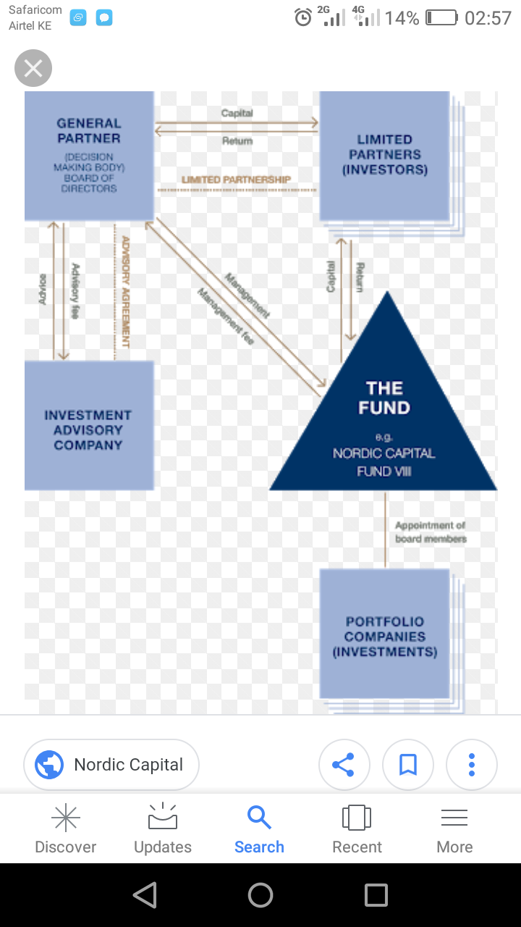
Fig 1: Proposed Investment Methodology
- Compliances
Compliance of all statutory regulations will be adhered to and followed to completion.
Areas of compliance will include:
Statutory number of investor for a select form of business
- Capacity of persons involved
- Shareholding Requirements
- Registration
- Registration Fees
- Tax Compliance, etc
- Business Dissolution
In the event the business needs to be dissolved, we will ensure that it is per the articles of association
Will give proper and effective business dissolution steps that are cost effective and satisfies all affected persons

